Networks Lab
Week 8
DNS Client Server
21BCE1889
Aditya Sai

UDP :
Server :
import csv
import socket

def read_dns_database(filename):
dns_database = {}
with open(filename, "r") as file:
reader = csv.reader(file)
for row in reader:
hostname, ip_address = row
dns_database[hostname] = ip_address
return dns_database

dns_database_filename = "dns_database.csv"
dns_port = 53
dns_socket = socket.socket(socket.AF_INET, socket.SOCK_DGRAM)
dns_socket.bind(("localhost", dns_port))
dns_database = read_dns_database(dns_database_filename)

print(f"DNS server is running on port {dns_port}...")
while True:

query, client_address = dns_socket.recvfrom(1024)
hostname = query.decode().strip()
ip_address = dns_database.get(hostname, "Hostname not found")
dns_socket.sendto(ip_address.encode(), client_address)

Client
import socket

dns_server_address = "localhost"
dns_server_port = 53

hostname = input("Enter domain name to search for: ")
client_socket = socket.socket(socket.AF_INET, socket.SOCK_DGRAM)
client_socket.sendto(hostname.encode(), (dns_server_address, dns_server_port))

response, server_address = client_socket.recvfrom(1024)
print(f"IP address for {hostname}: {response.decode()}")

client_socket.close()

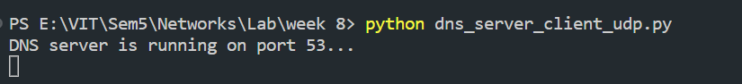
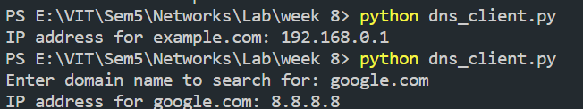

TCP :

Server :
import csv
import socket

def read_dns_database(filename):
dns_database = {}
with open(filename, "r") as file:
reader = csv.reader(file)
for row in reader:
hostname, ip_address = row
dns_database[hostname] = ip_address
return dns_database

dns_database_filename = "dns_database.csv"
dns_port = 53

dns_socket = socket.socket(socket.AF_INET, socket.SOCK_STREAM)
dns_socket.bind(("localhost", dns_port))
dns_socket.listen(1)
dns_database = read_dns_database(dns_database_filename)
print(f"DNS server is running on port {dns_port}...")

while True:
client_socket, client_address = dns_socket.accept()
print(f"Connection established with {client_address[0]}:{client_address[1]}")
query = client_socket.recv(1024).decode().strip()

ip_address = dns_database.get(query, "Hostname not found")
client_socket.send(ip_address.encode())
client_socket.close()

Client
import socket

dns_server_address = "localhost"
dns_server_port = 53

hostname = input("Enter domain name to search for: ")

client_socket = socket.socket(socket.AF_INET, socket.SOCK_STREAM)
client_socket.connect((dns_server_address, dns_server_port))
client_socket.send(hostname.encode())
response = client_socket.recv(1024).decode()
print(f"IP address for {hostname}: {response}")
client_socket.close()

